Photo Analysis Instructions

1. Open ImageJ and check if the measurements are correct. Go to Analyze then Set Measurements

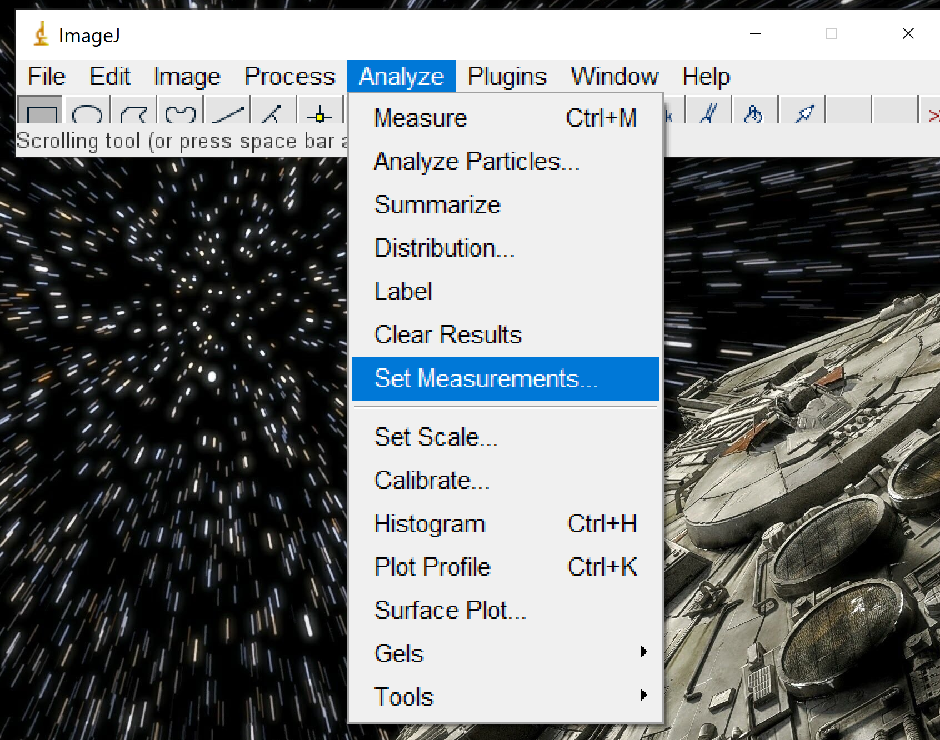

1. Check that at least Mean Gray Value is checked off and then click OK at the bottom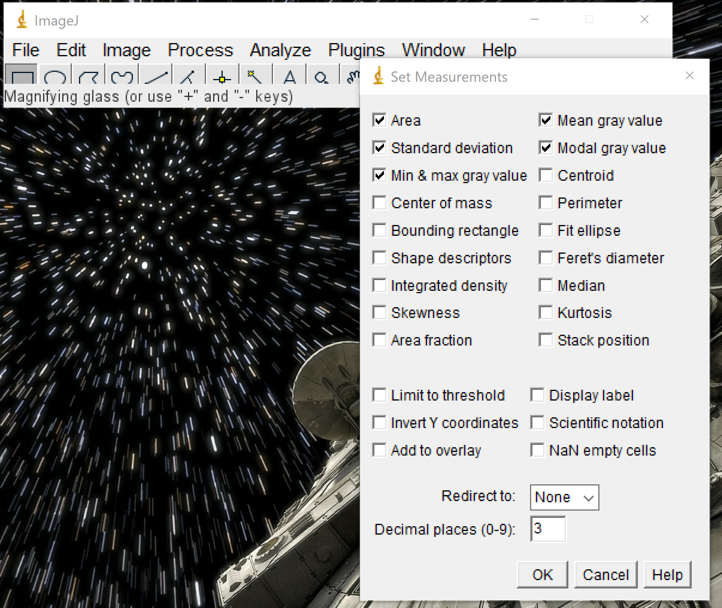
2. Go to File then Open… to open a file

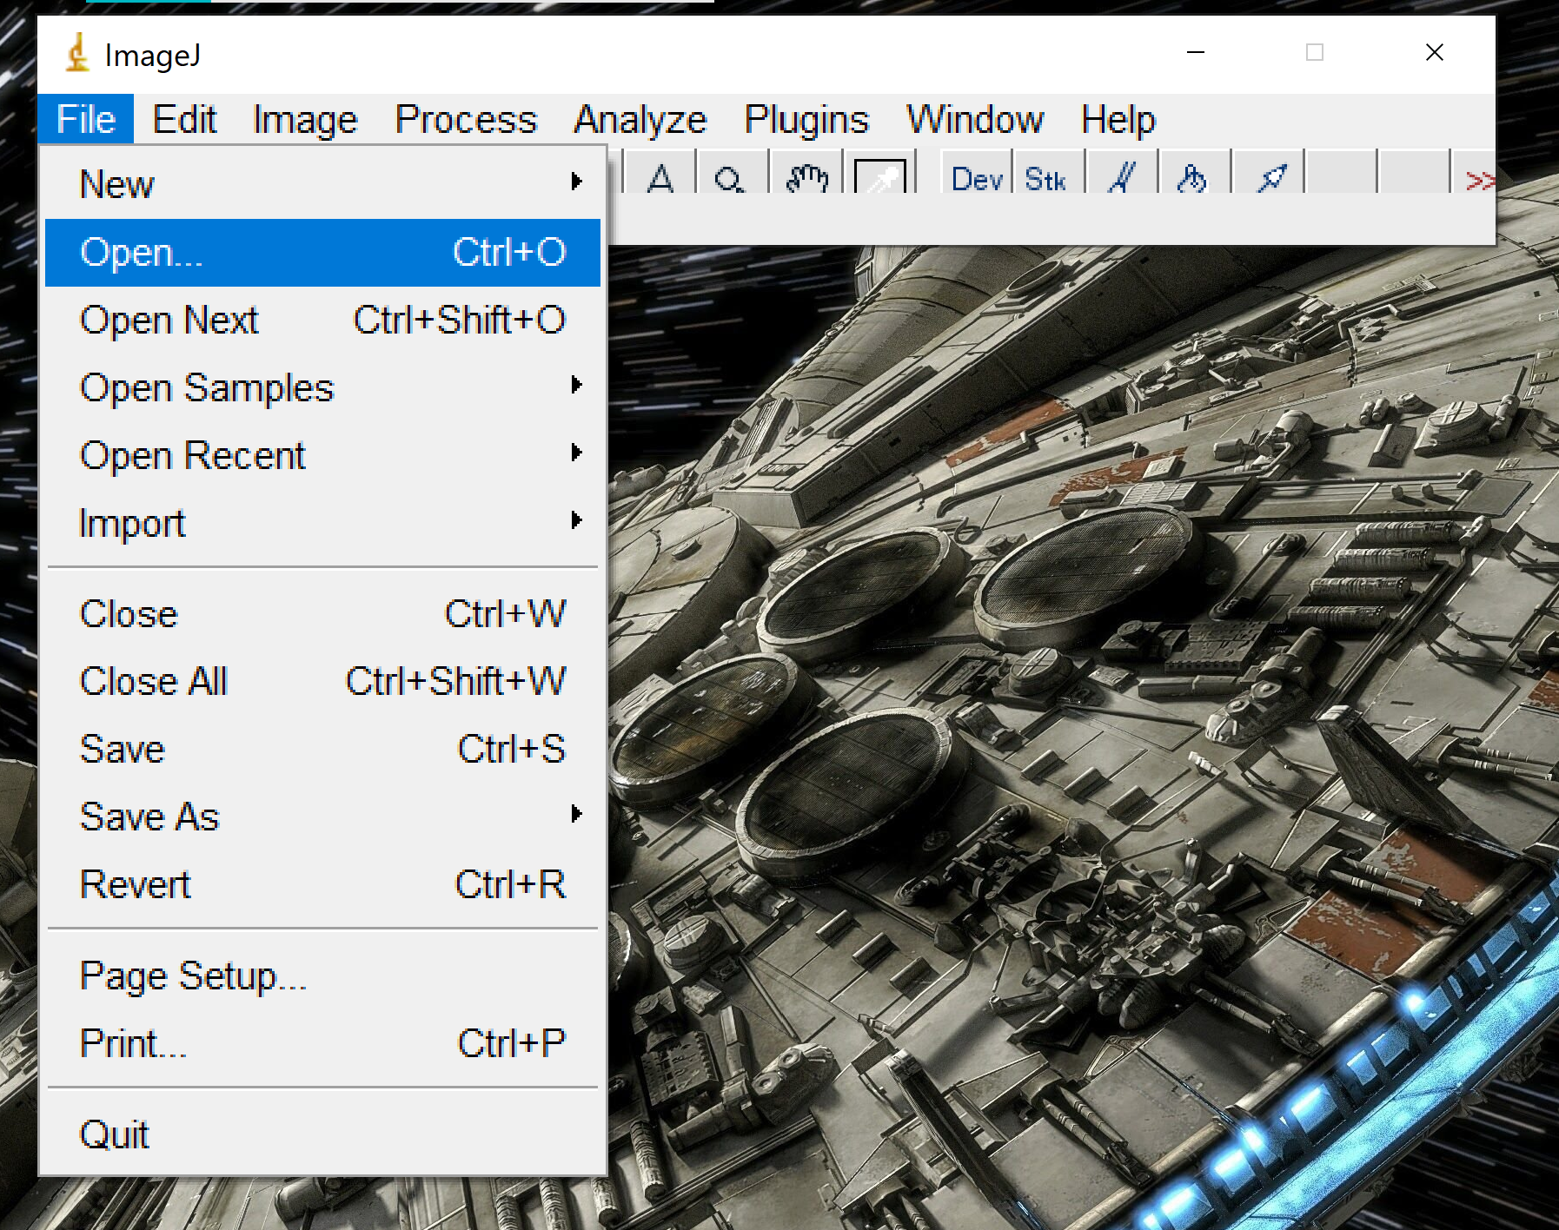

1. Choose the File from the GitHub Folder you are going to analyze. Once open it should look like the photo below.

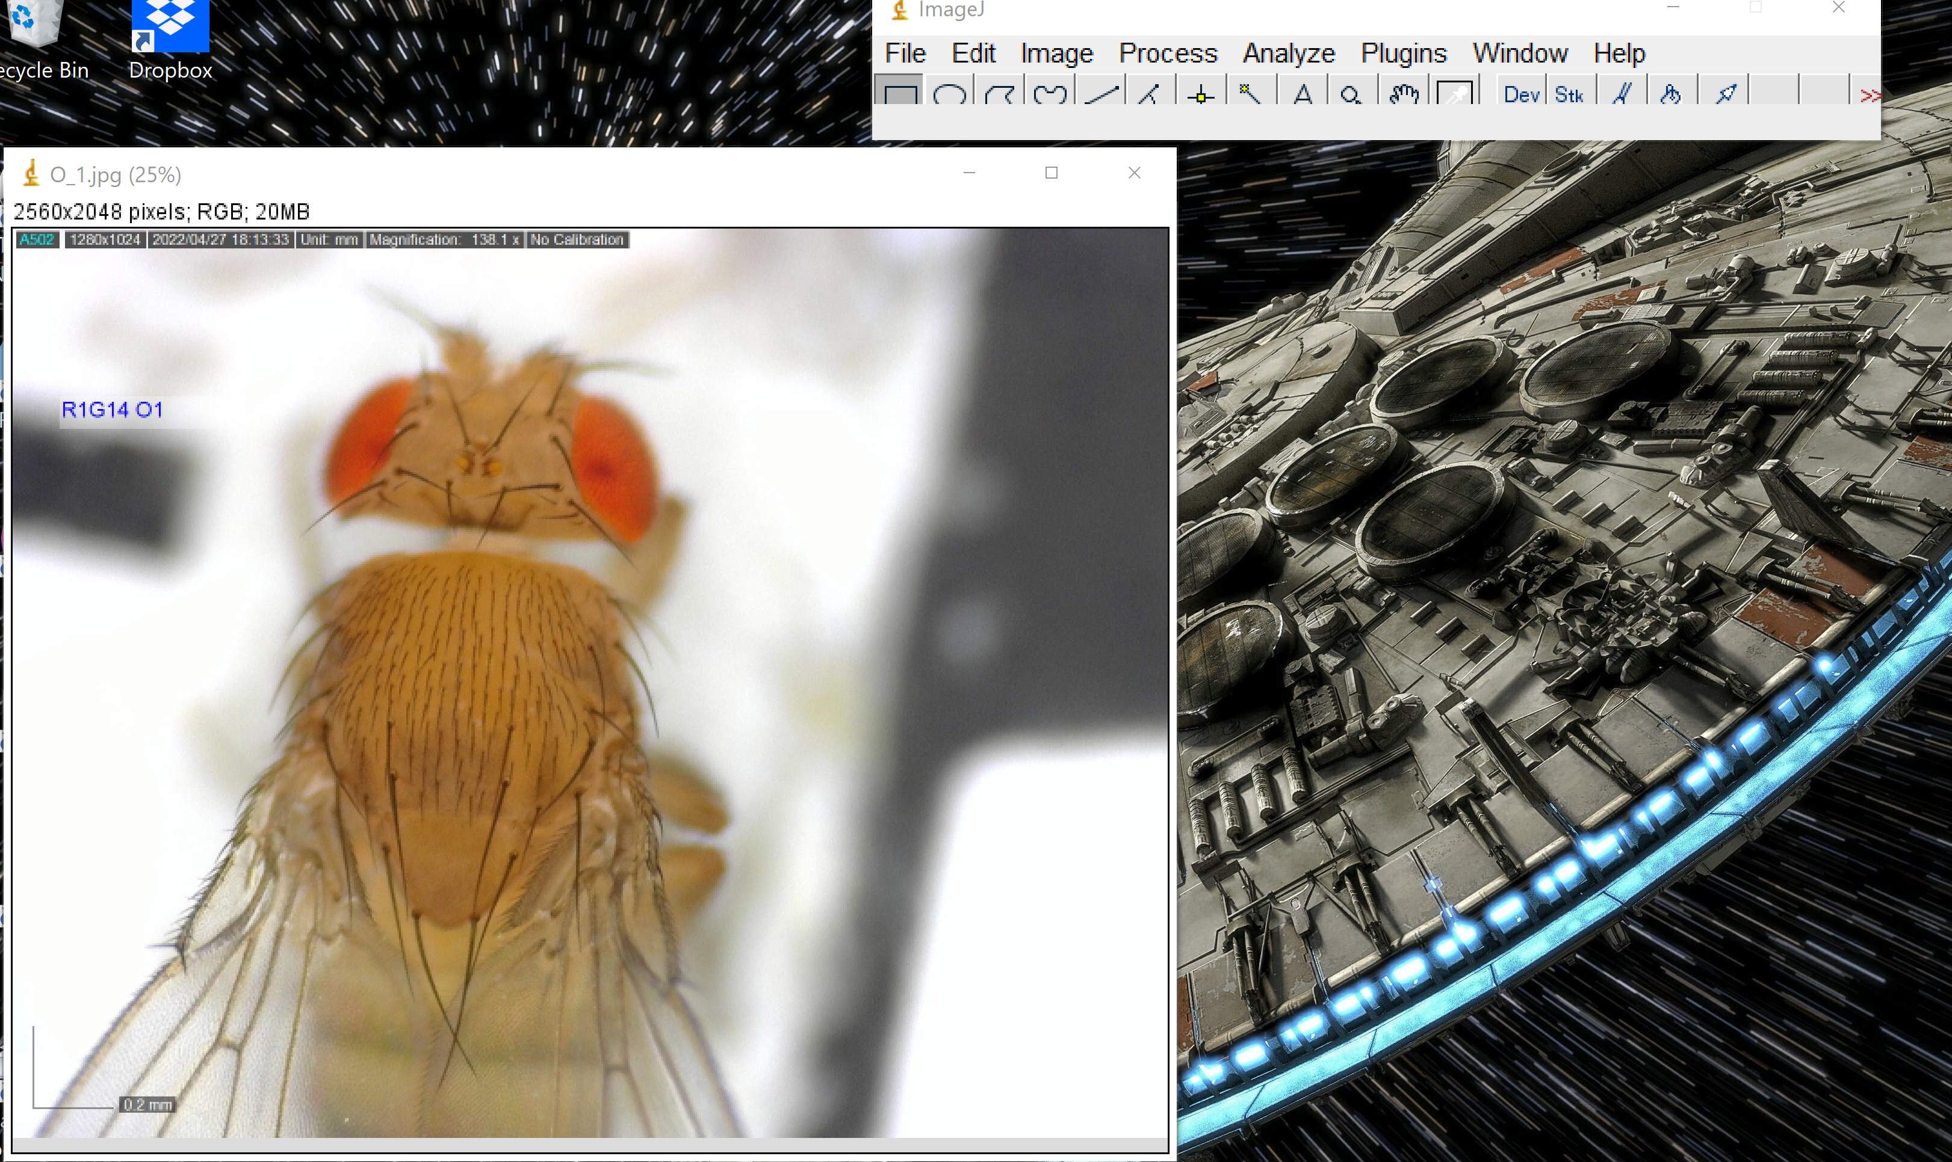

1. Convert the photo to 8-bit by going to Image then Type and clicking 8-bit. Once you have clicked this, the image will become black and white.

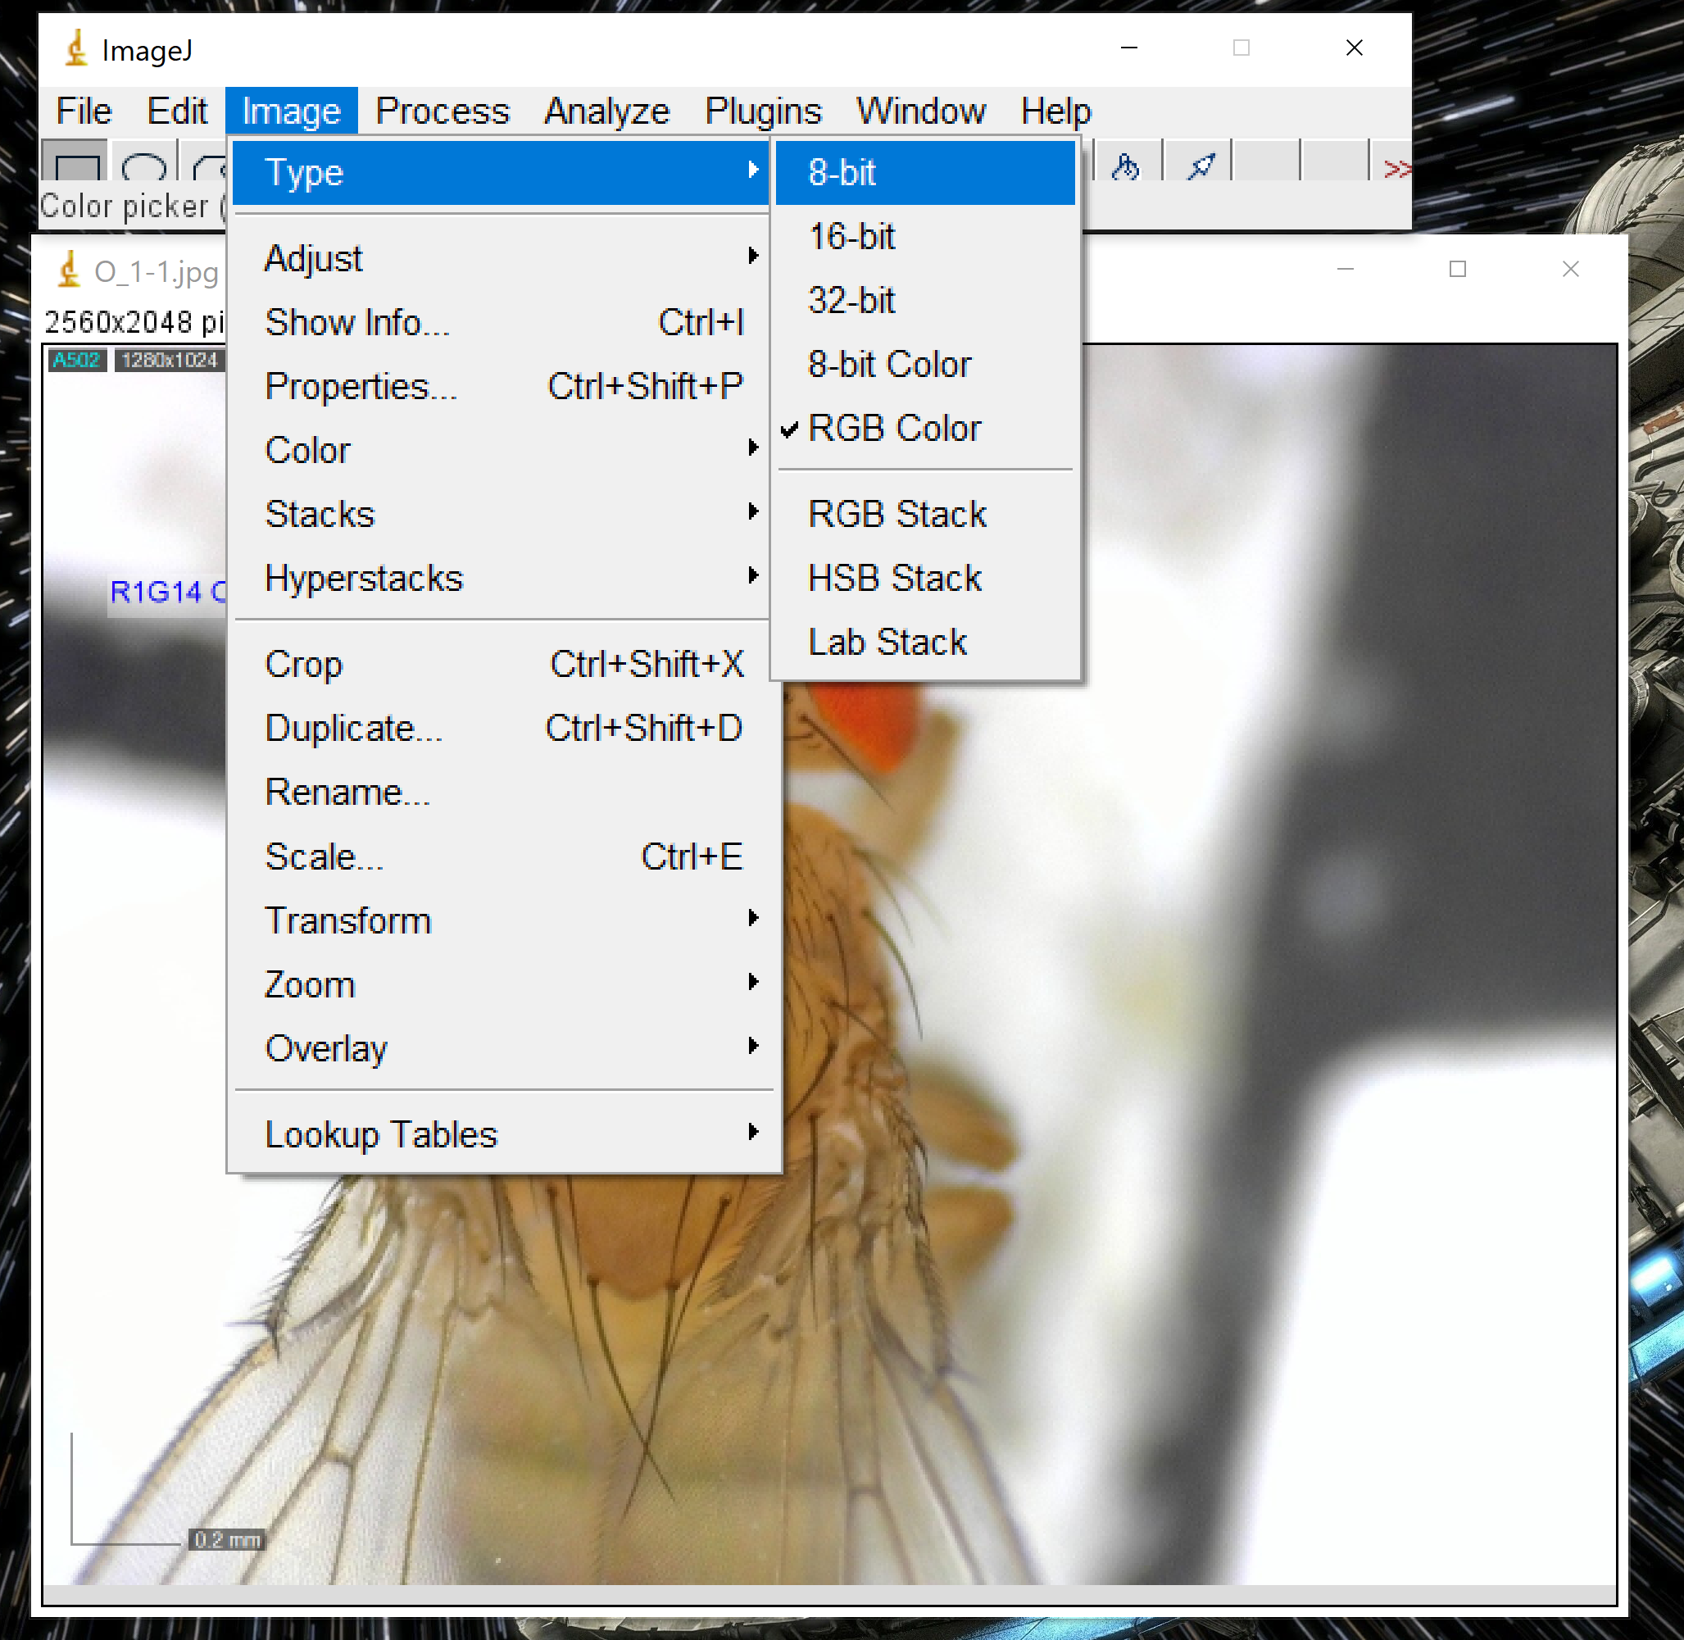

1. Using the rectangle that is already selected, create a box in the darkest black part.

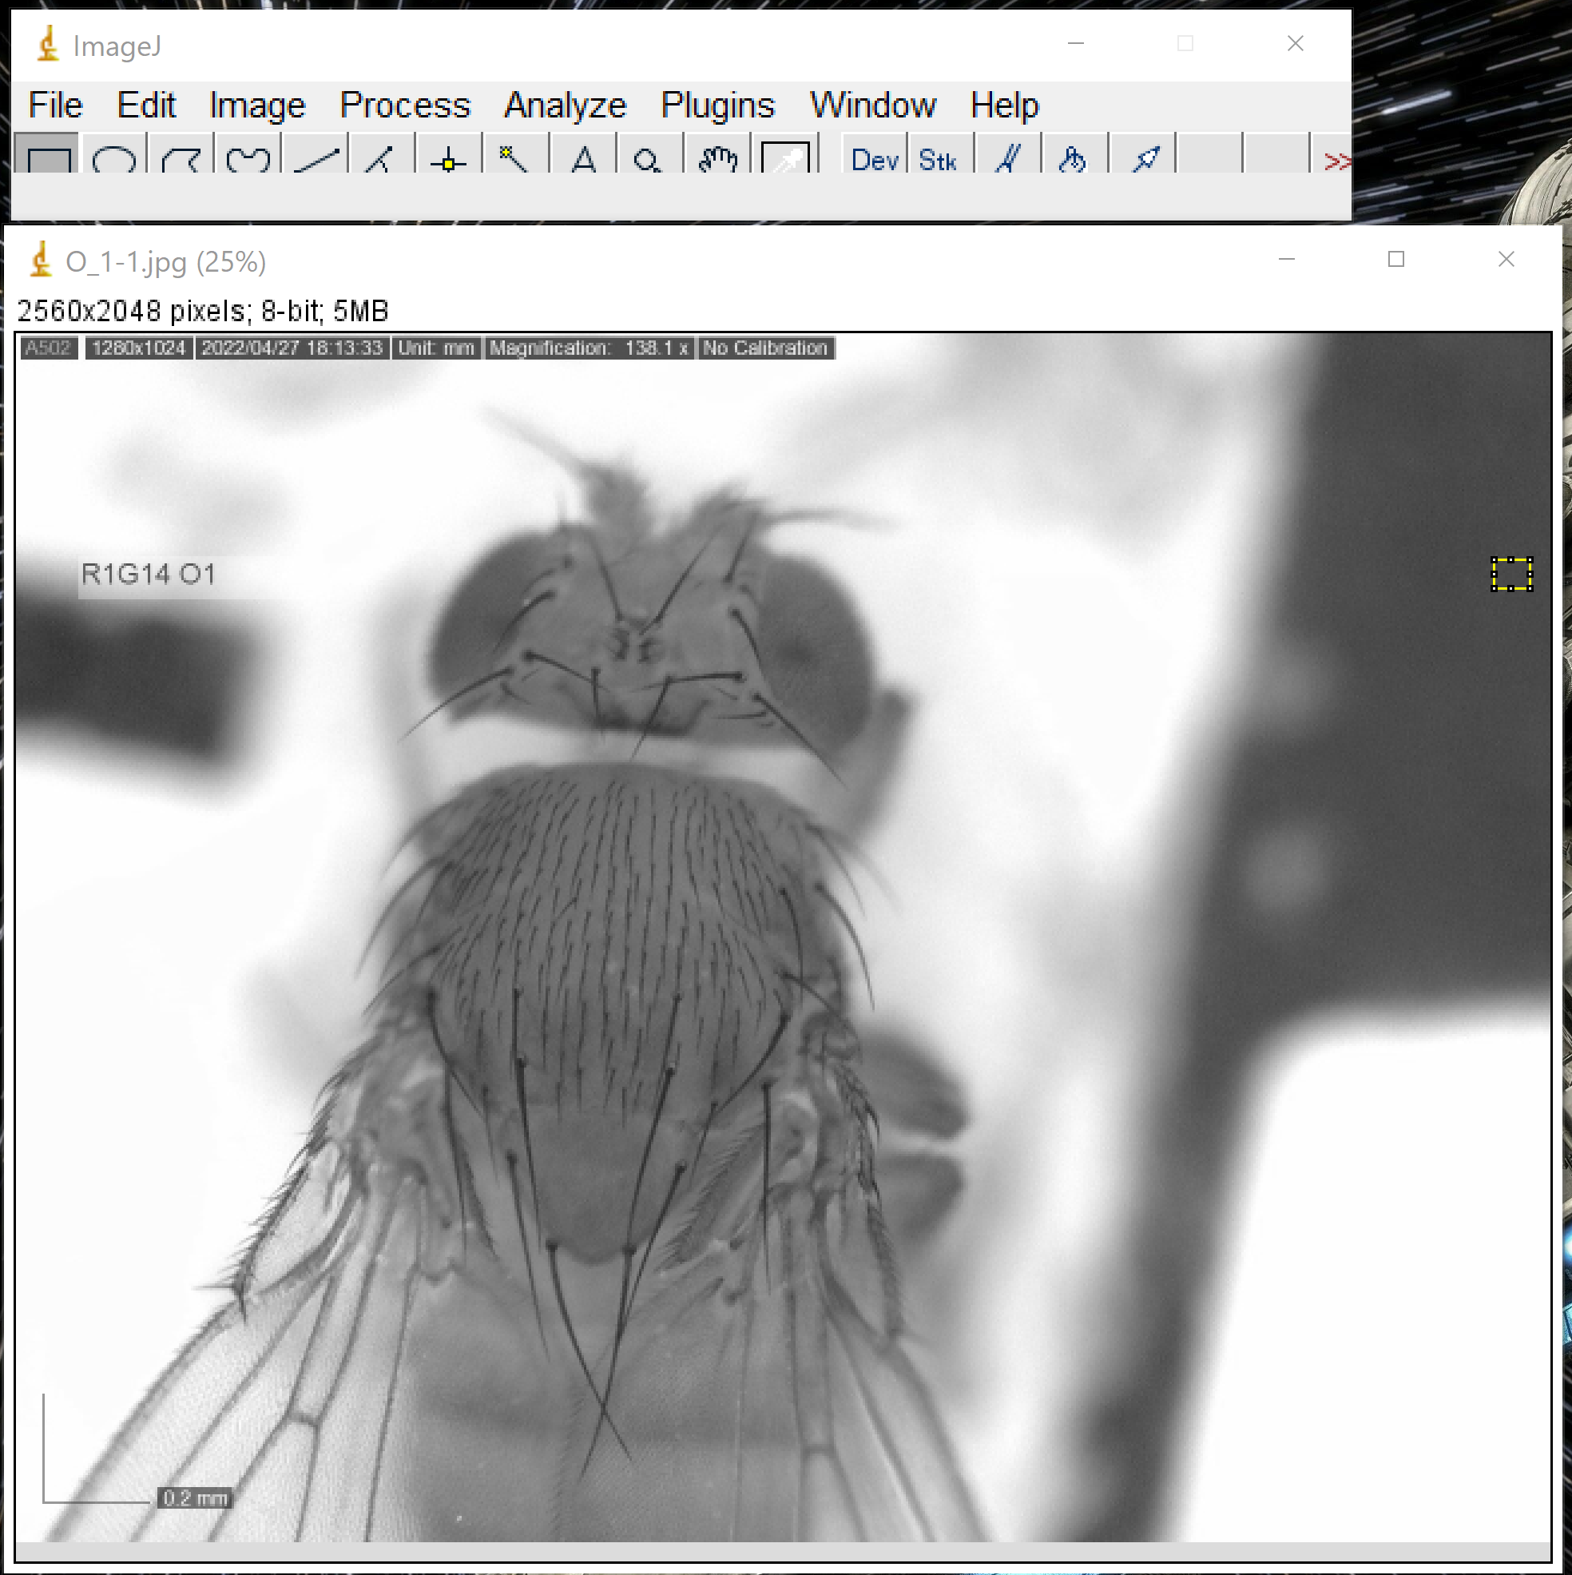

1. Then go to Analyze and then Measure

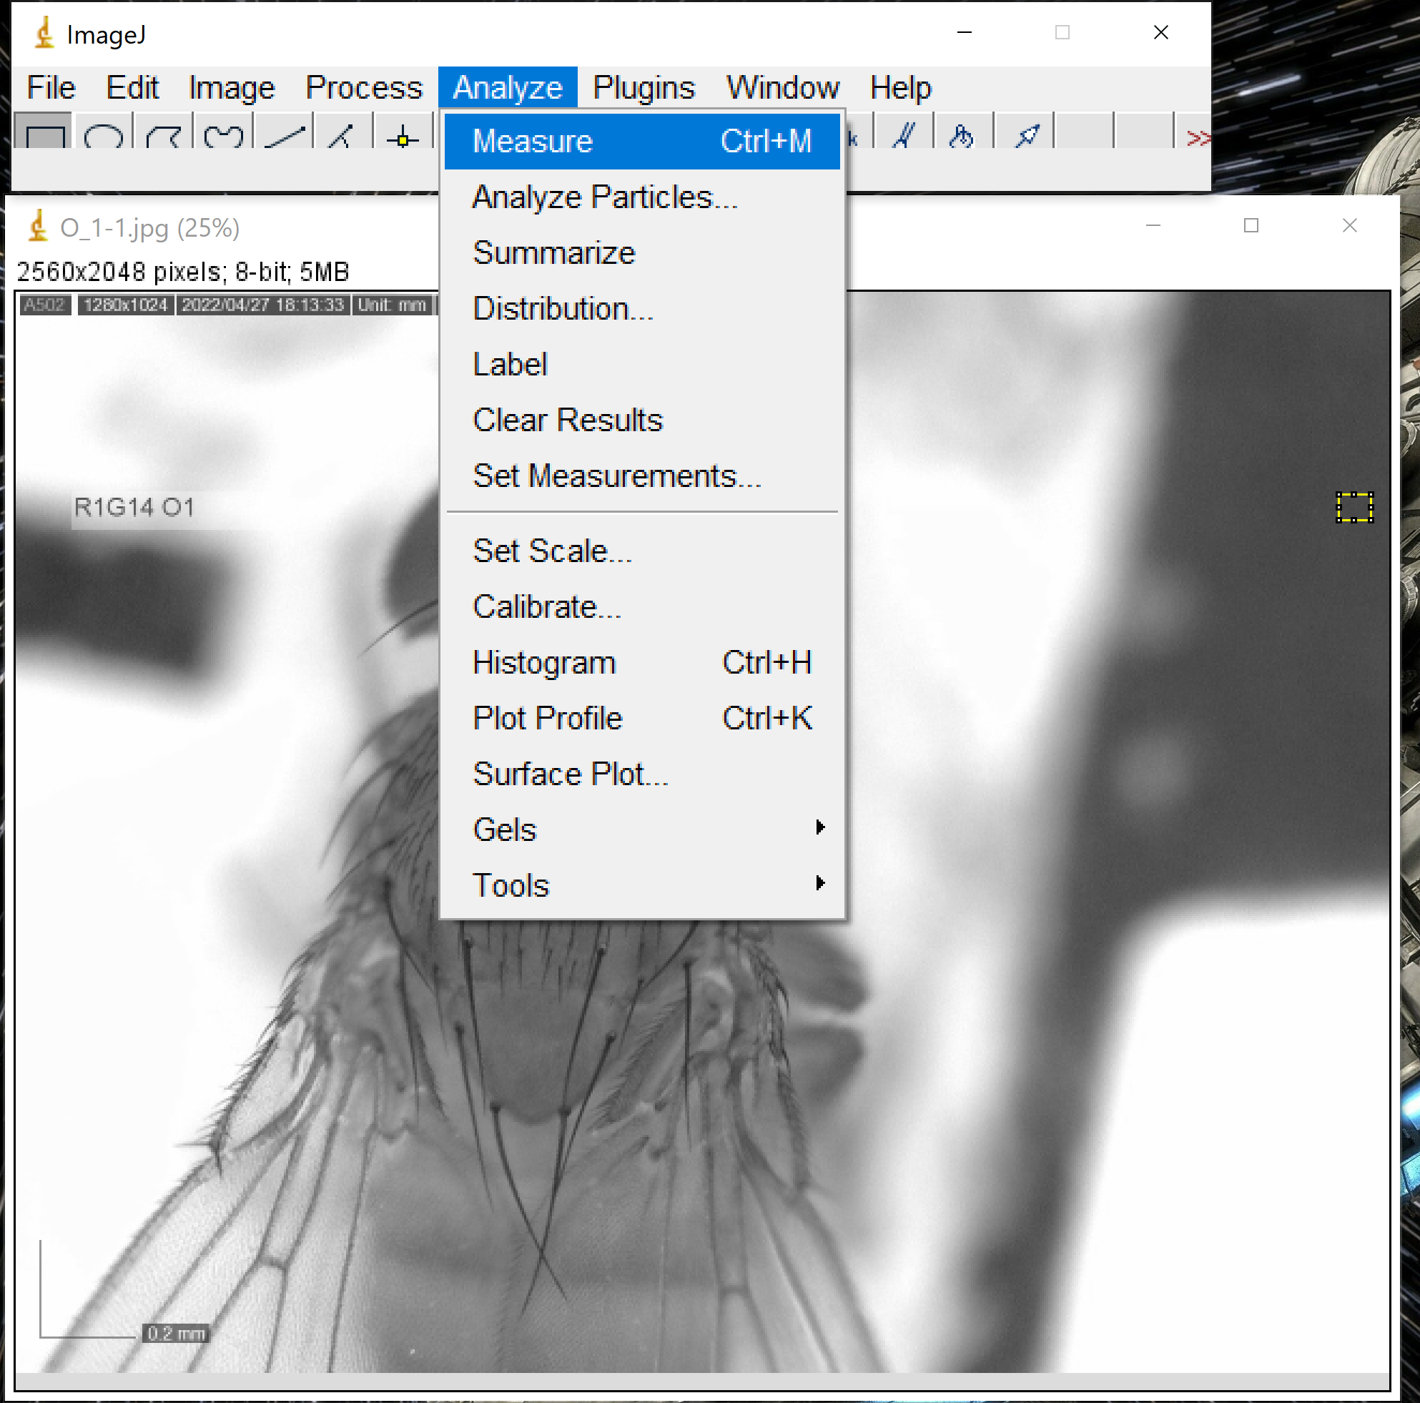

1. Once you click Measure a table should pop up with the mean greyscale value.

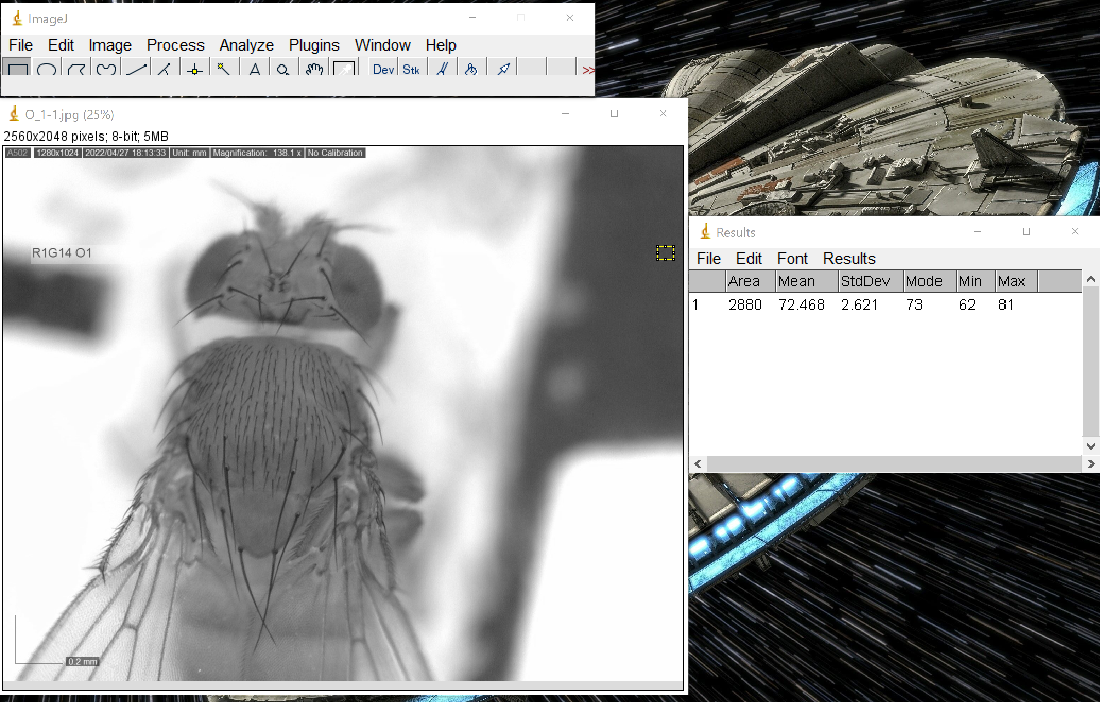

1. Repeat this process for the white standard. (Steps 6-7) Using the rectangle that is already selected, create a box in the darkest black part on the left.

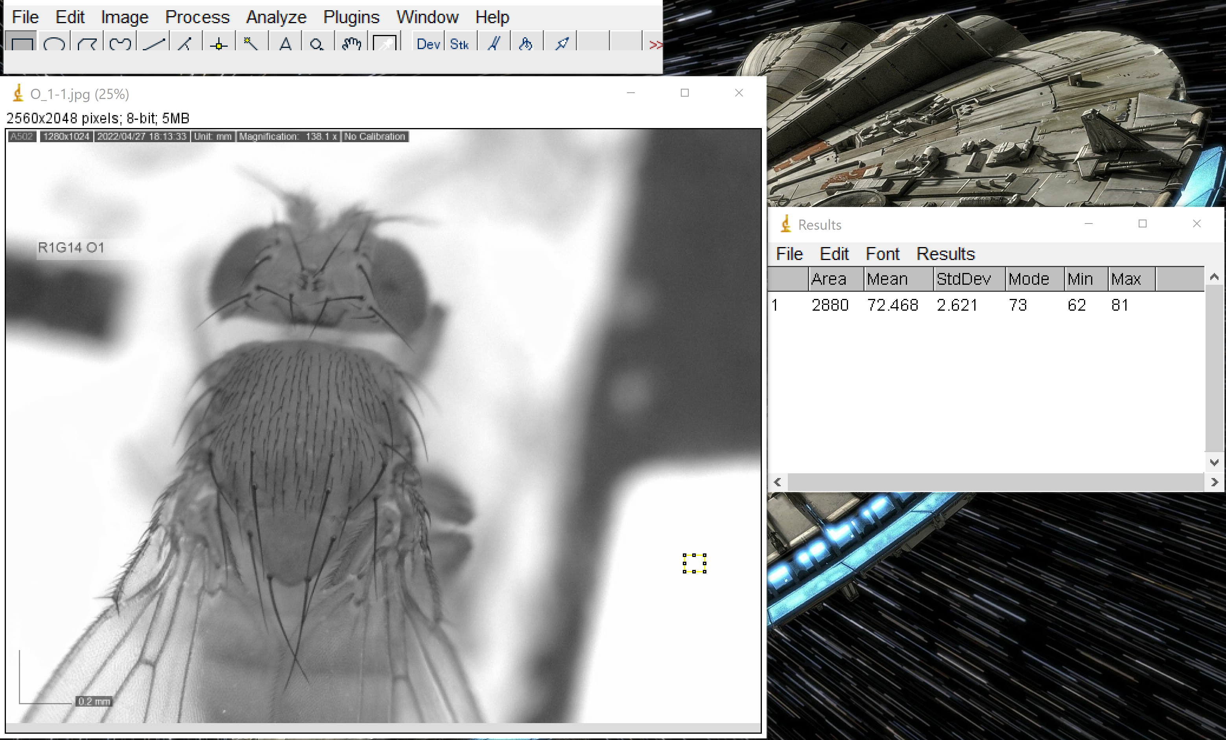

1. Then go to Analyze and then Measure

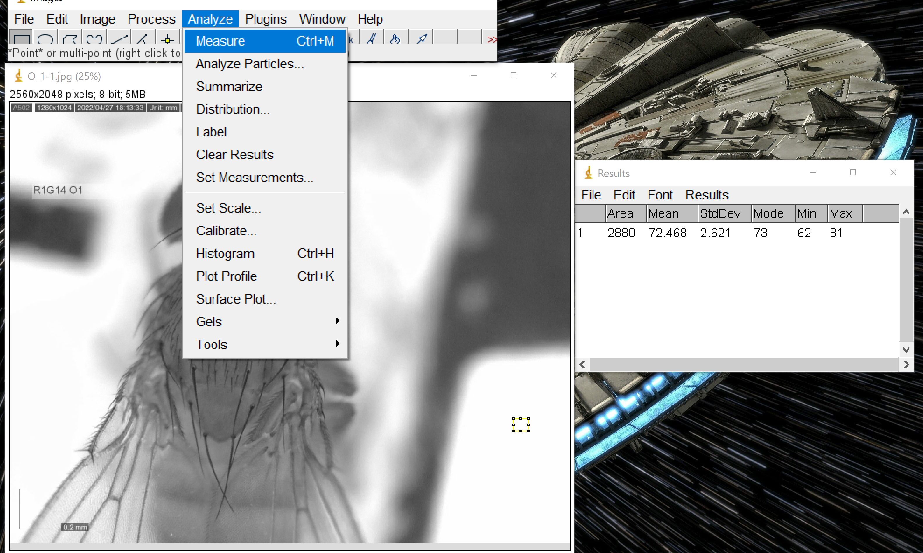

1. Once you click Measure the table will add a second row with the mean greyscale value.

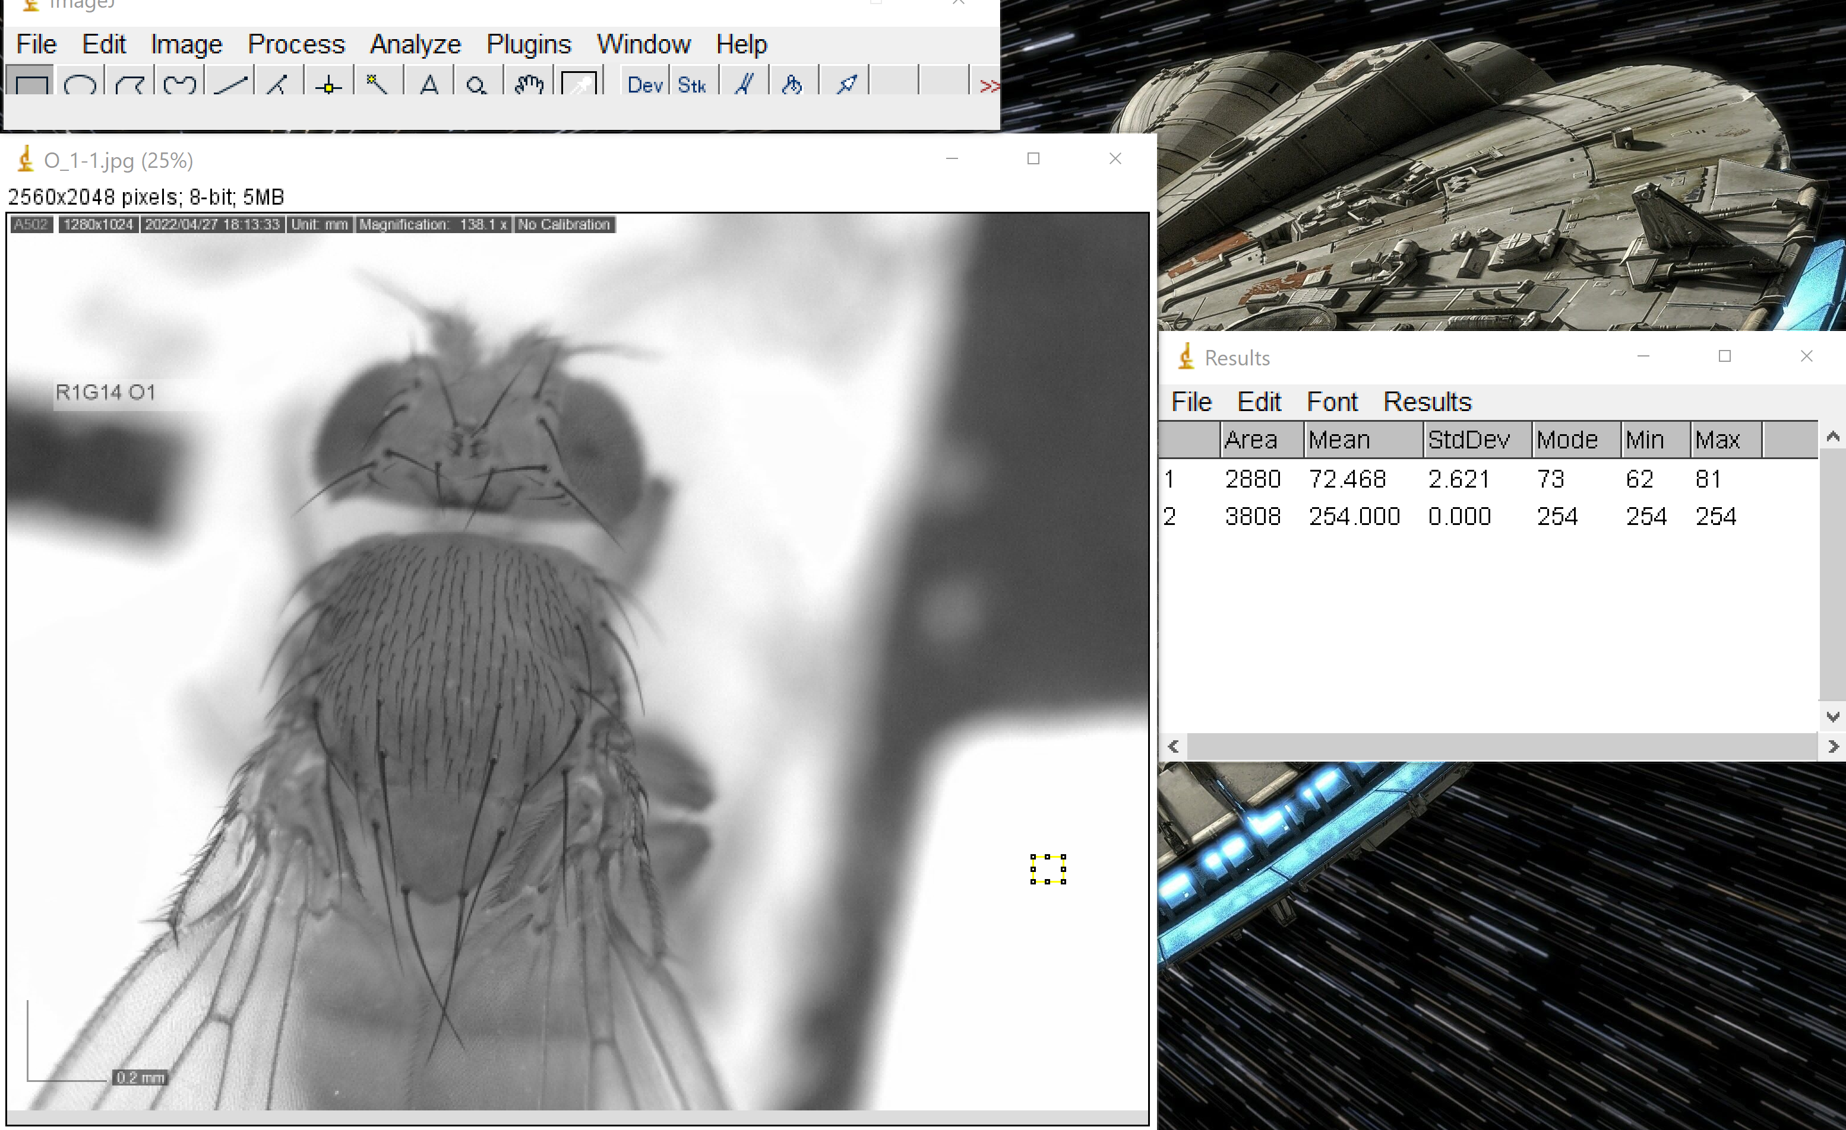

1. Once you have those two values measured, Go to Analyze then Calibrate…

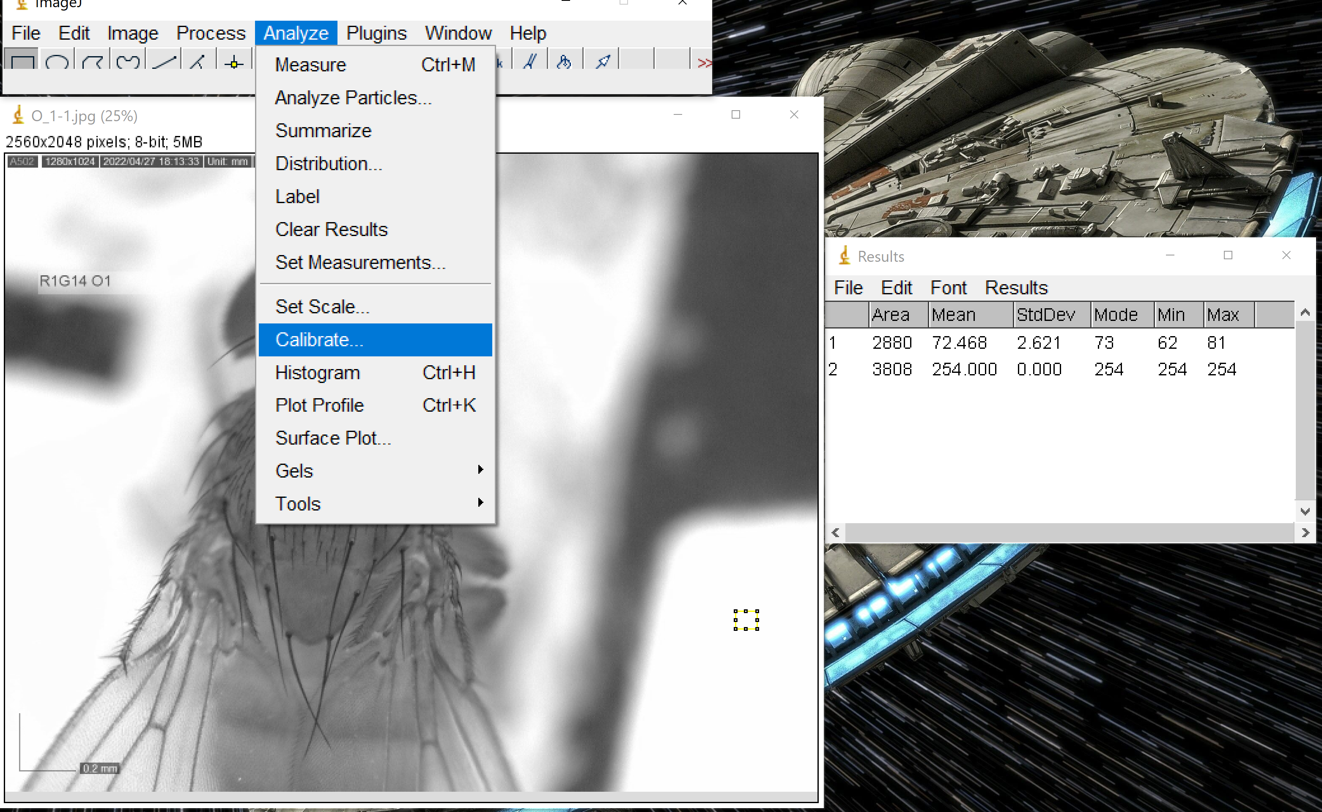

1. A new table should pop up. Once you see this table, change the function to straight line. Change unit to gray value if it is not already there. In the right column add the values of 0 to correspond to the black measure from the left column and 255 for the white in the right column. Then click OK at the bottom of the table.

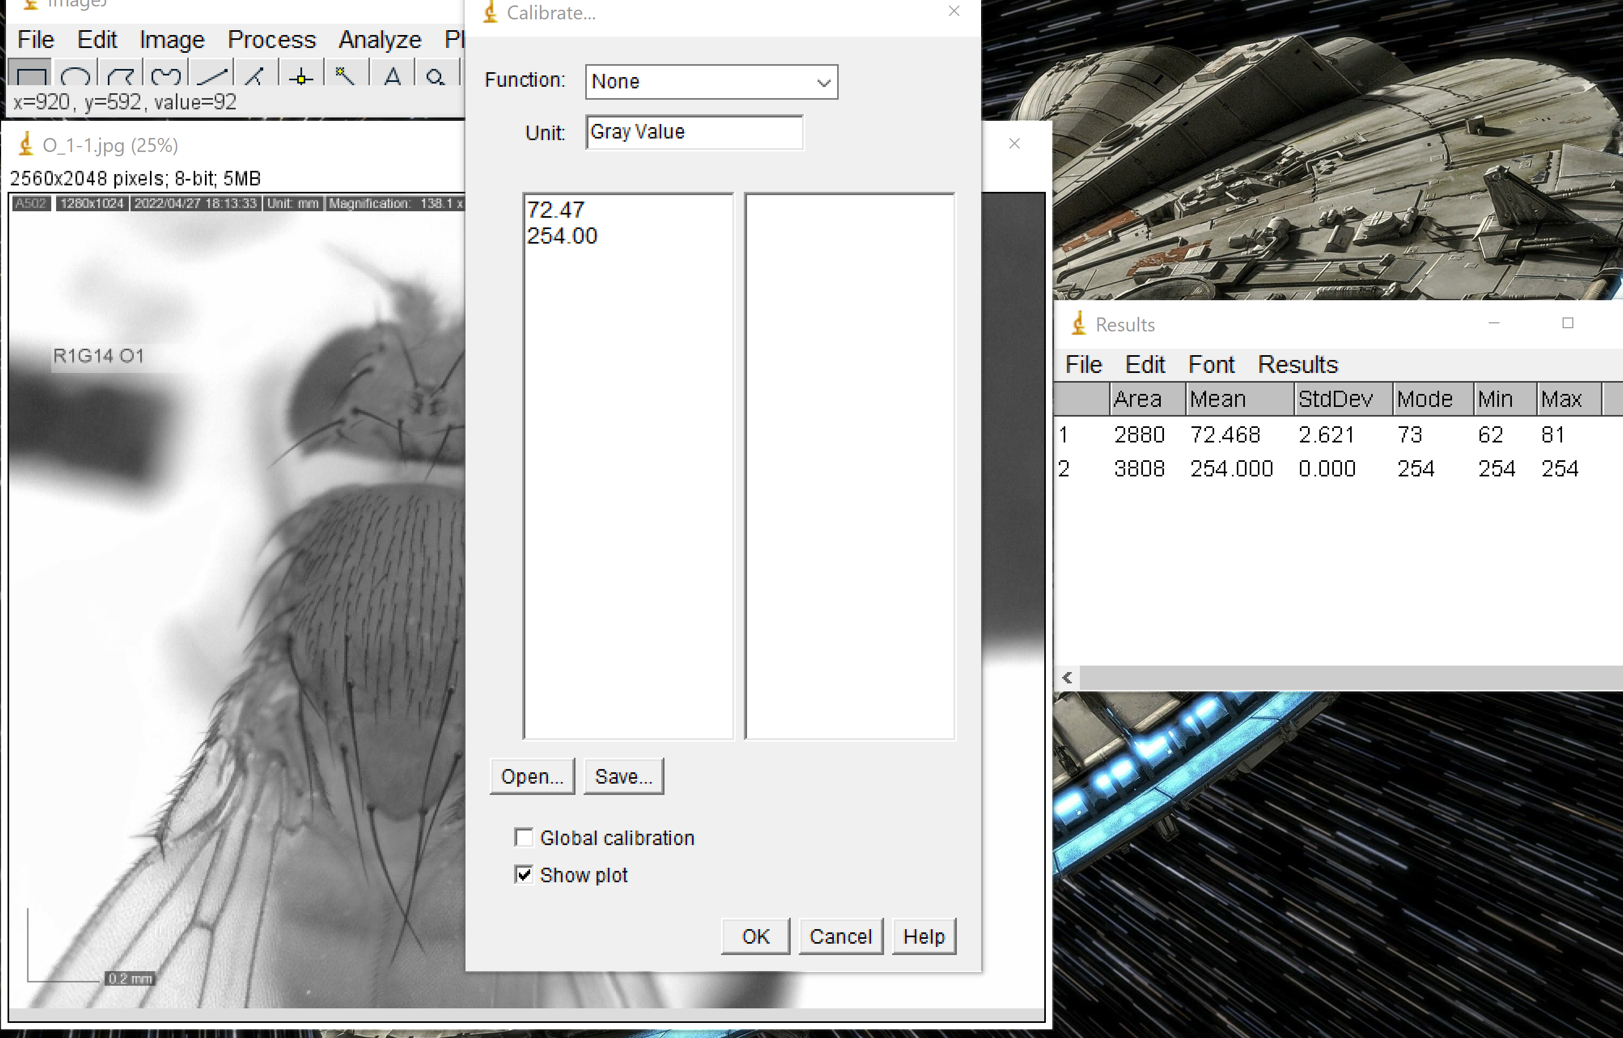

WHEN FINISHED:

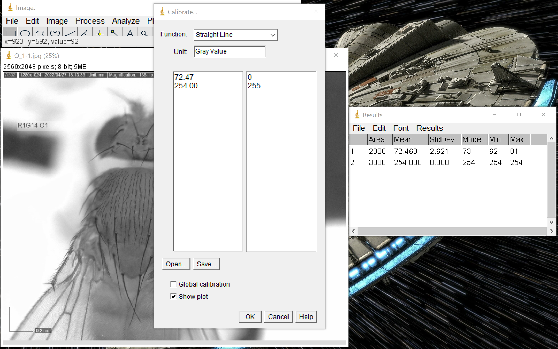

1. Once you have finished, the table will disappear, and a plot should pop up. You can close this window.

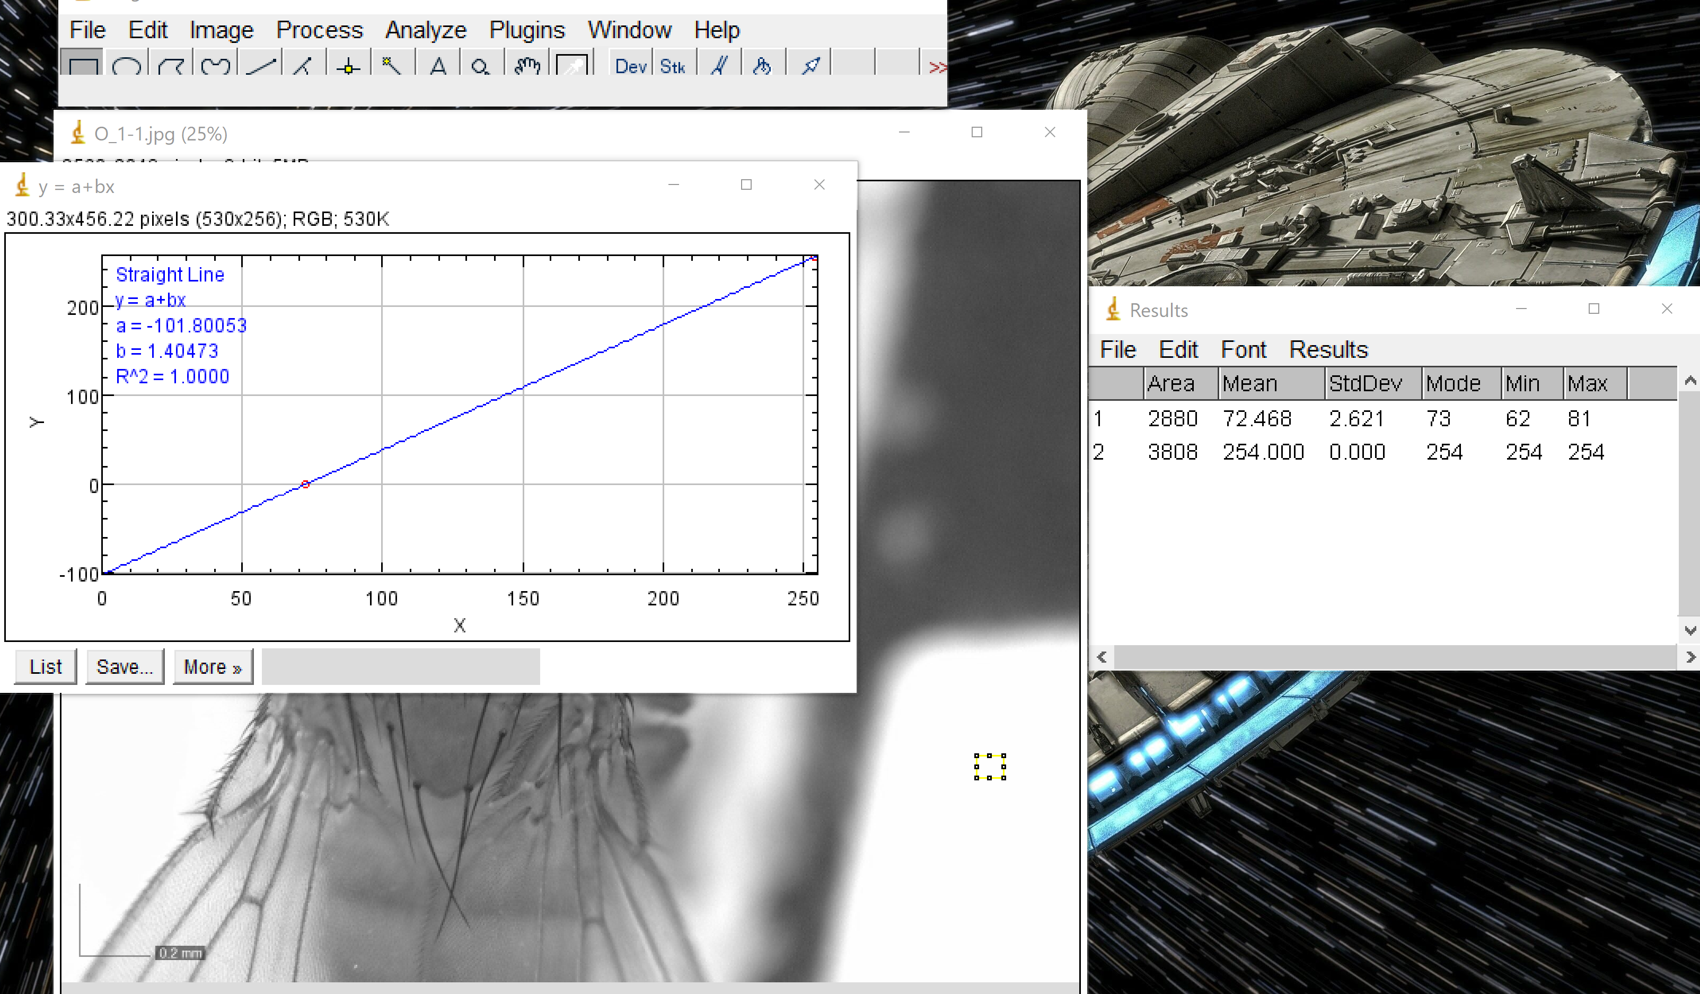

1. Check calibration. Re-measure white rectangle. See steps 8-9. You should see that the new value is 255 (what we changed it to).

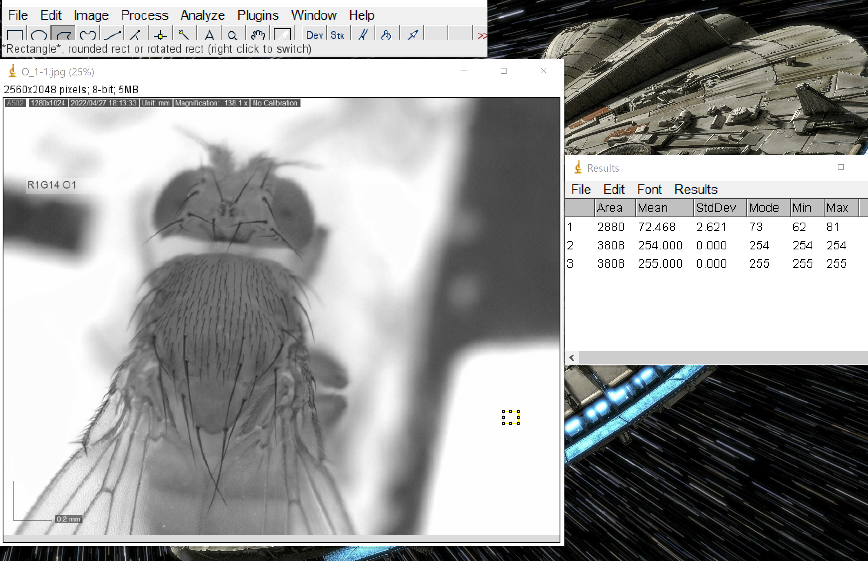

1. Repeat the process for measuring the trident. (Steps 6-7) Instead of the rectangle, we will use the freeform selection.

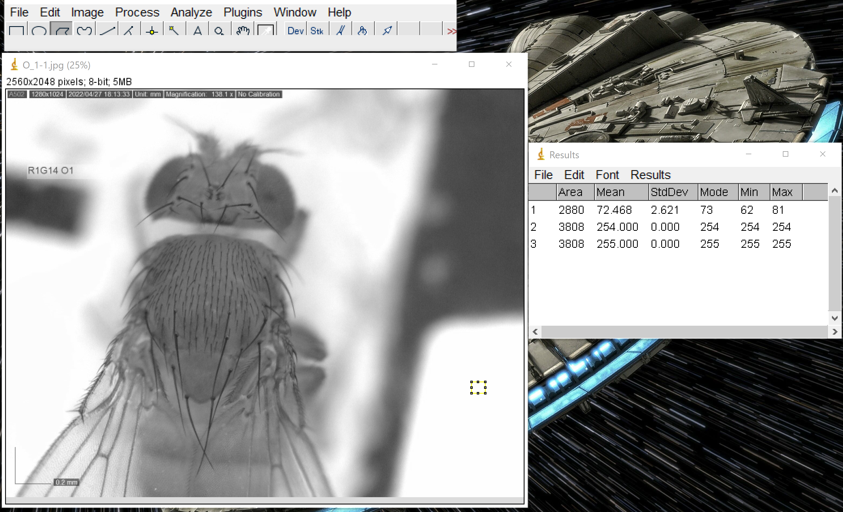

1. Using the freeform tool, mark the lower four bristles on the back of the thorax.

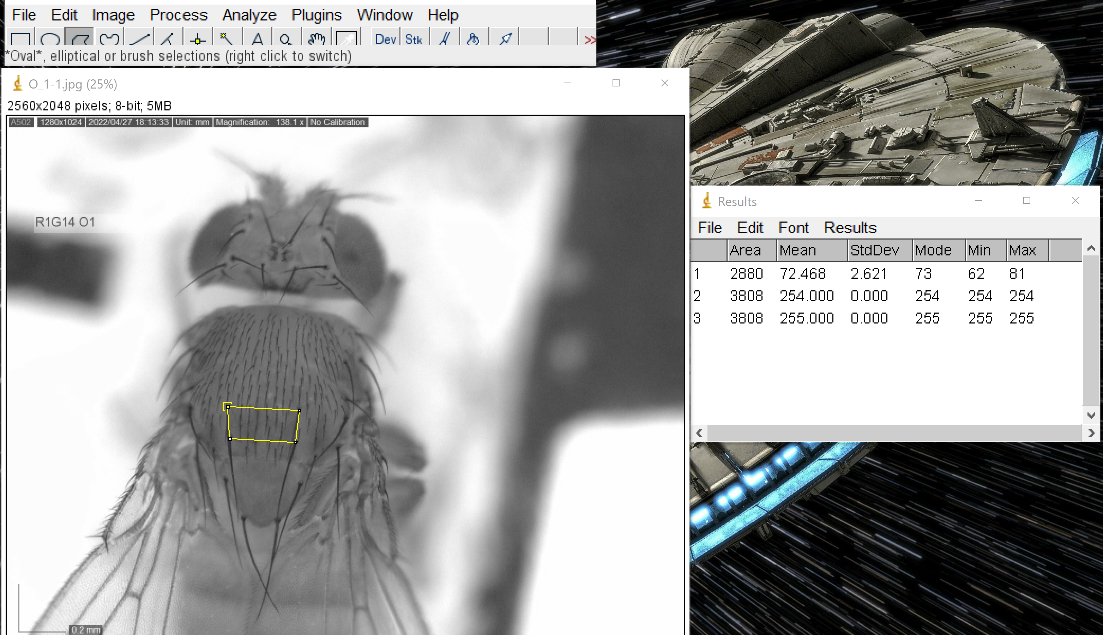

1. Then go to Analyze and then Measure.

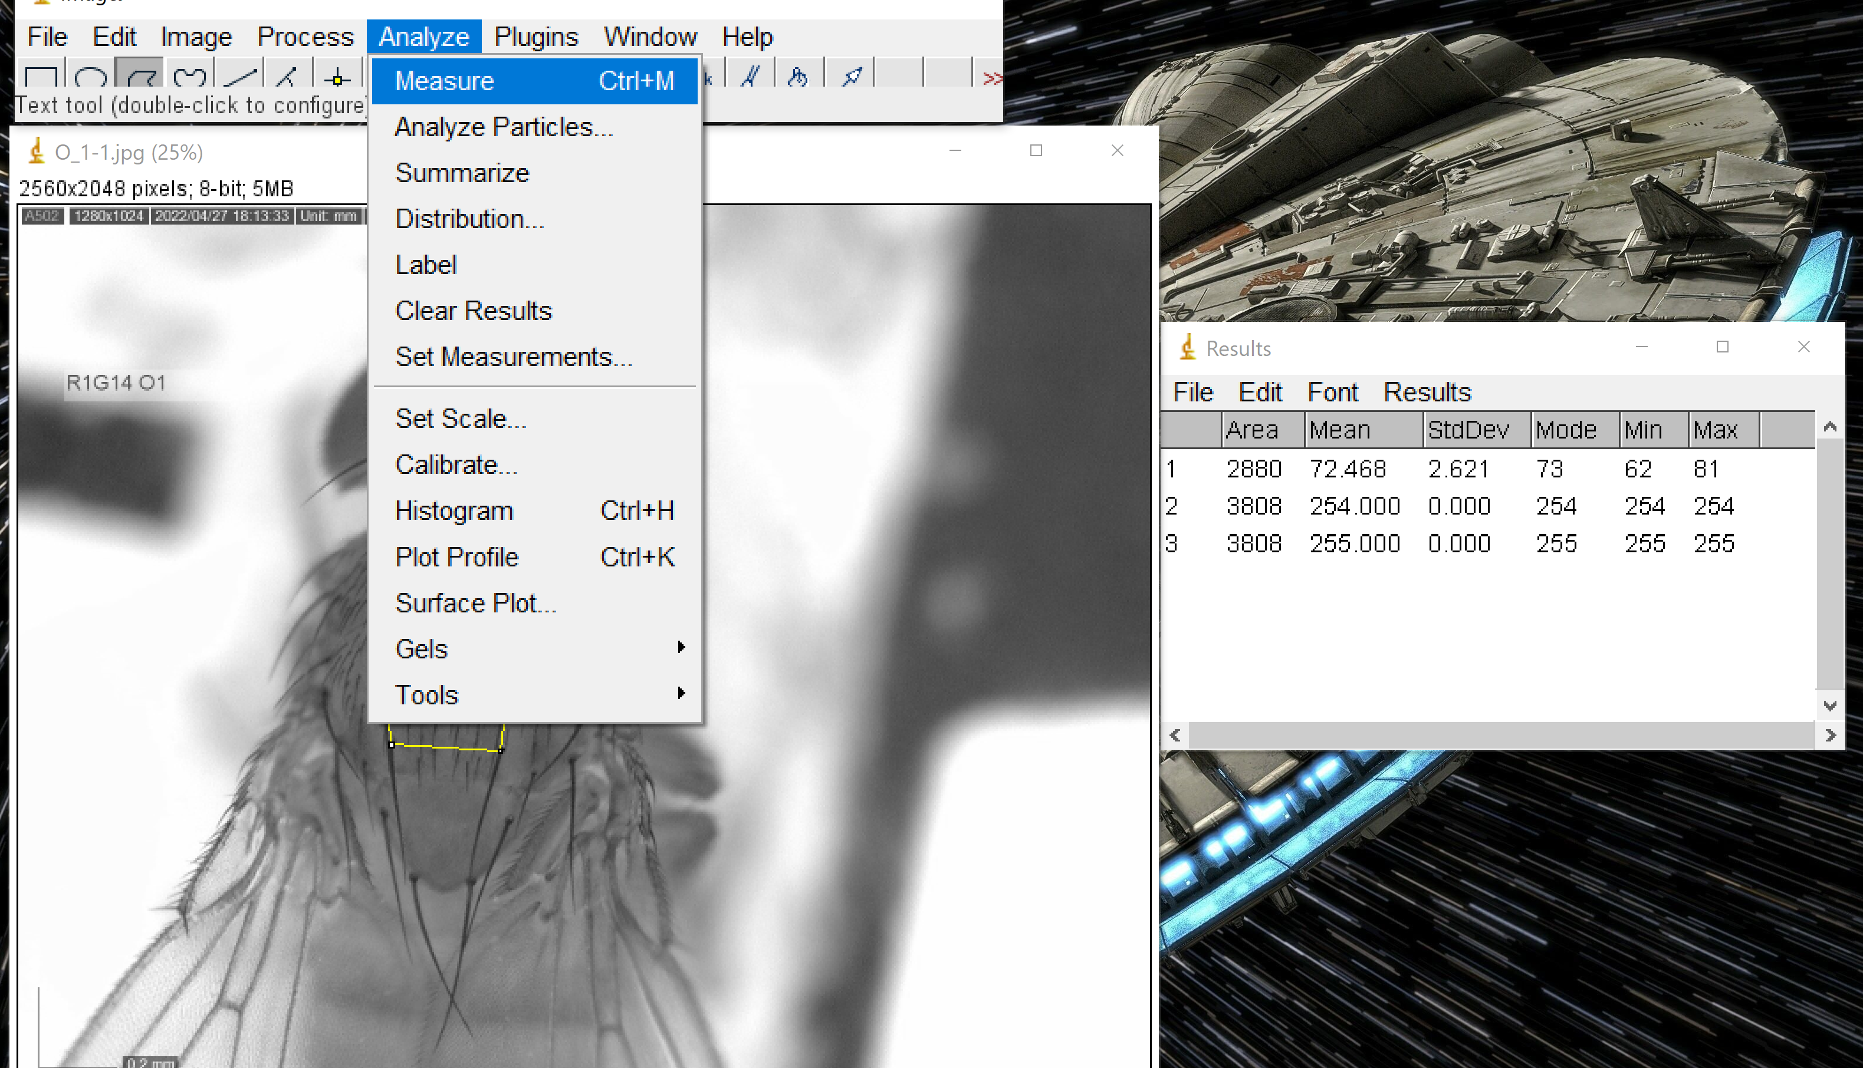

1. The table will add a fourth row with the mean greyscale value.

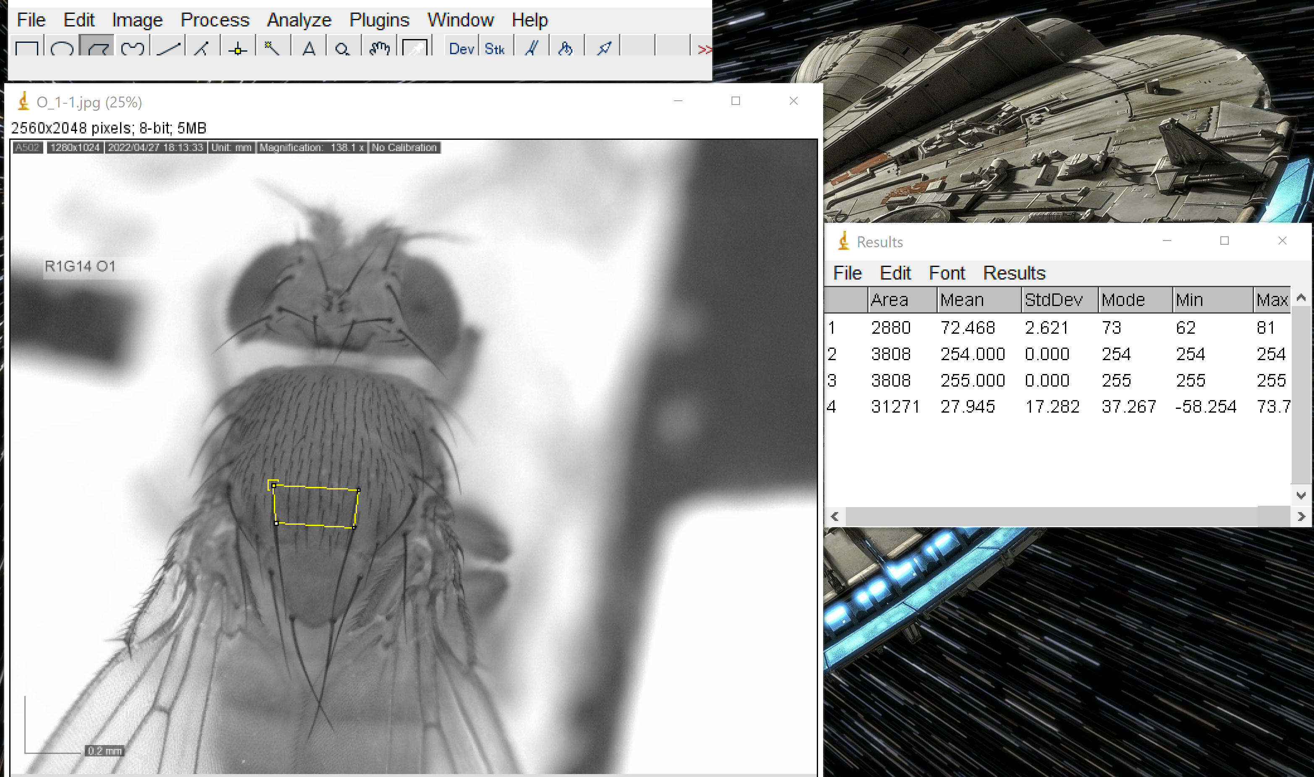

1. On the google doc, record the original black, gray scale value, original white, gray scale value, and trident gray scale value. Repeat the entire process for each photo.